Partlist
Exported from untitled.brd at 17/11/2014 17:43:44
EAGLE Version 6.1.0 Copyright (c) 1988-2012 CadSoft

Part Value Package Library Position (mm) Orientation

C1 100n C3225 rcl (90.17 39.37) MR270
C2 100n C3225 rcl (71.12 48.26) R180
C3 100n C3225 rcl (63.5 48.26) R0
C4 47u E-01 ITIVINCI (71.12 53.34) R180
C5 100n C3225 rcl (82.55 38.1) MR270
C7 47u E-01 ITIVINCI (63.5 53.34) R0
D1 SD LED5MM ITIVINCI (100.33 57.15) R180
D2 CAN LED5MM ITIVINCI (100.33 41.91) R180
D3 GSM LED5MM ITIVINCI (100.33 49.53) R180
IC1 ARDUINO2009 arduino (21.59 20.32) R0
IC2 MEGA_ARDUINO arduino (21.59 24.13) R0
IC3 SN55HVD251 DIL8 microchip_can (82.55 39.37) R90
R1 4k7 M1206 rcl (93.98 64.77) R180
R2 10k M1206 rcl (93.98 69.85) R0
R3 1k M1206 rcl (106.68 41.91) R270
R4 1k M1206 rcl (106.68 57.15) R270
R5 1k M1206 rcl (106.68 49.53) R270
R6 4k7 M1206 rcl (99.06 33.02) R180
R7 10k M1206 rcl (106.68 33.02) R0
R8 10k M1206 rcl (26.67 27.94) MR270
R9 10k M1206 rcl (43.18 27.94) MR270
SV1 ICSP MA03-2 con-lstb (86.487 52.07) R270
SV2 CANA MA04-1 con-lstb (93.98 17.78) R0
SV3 CANB MA04-1 con-lstb (106.68 17.78) R0
SV4 CANC MA04-1 con-lstb (119.38 17.78) R0
SV5 I2CA MA05-1 con-lstb (29.21 17.78) R0
SV6 I2CA MA05-1 con-lstb (45.72 17.78) R0
U$2 SD_CARD SD ITIVINCI (35.56 50.8) R270

Layout

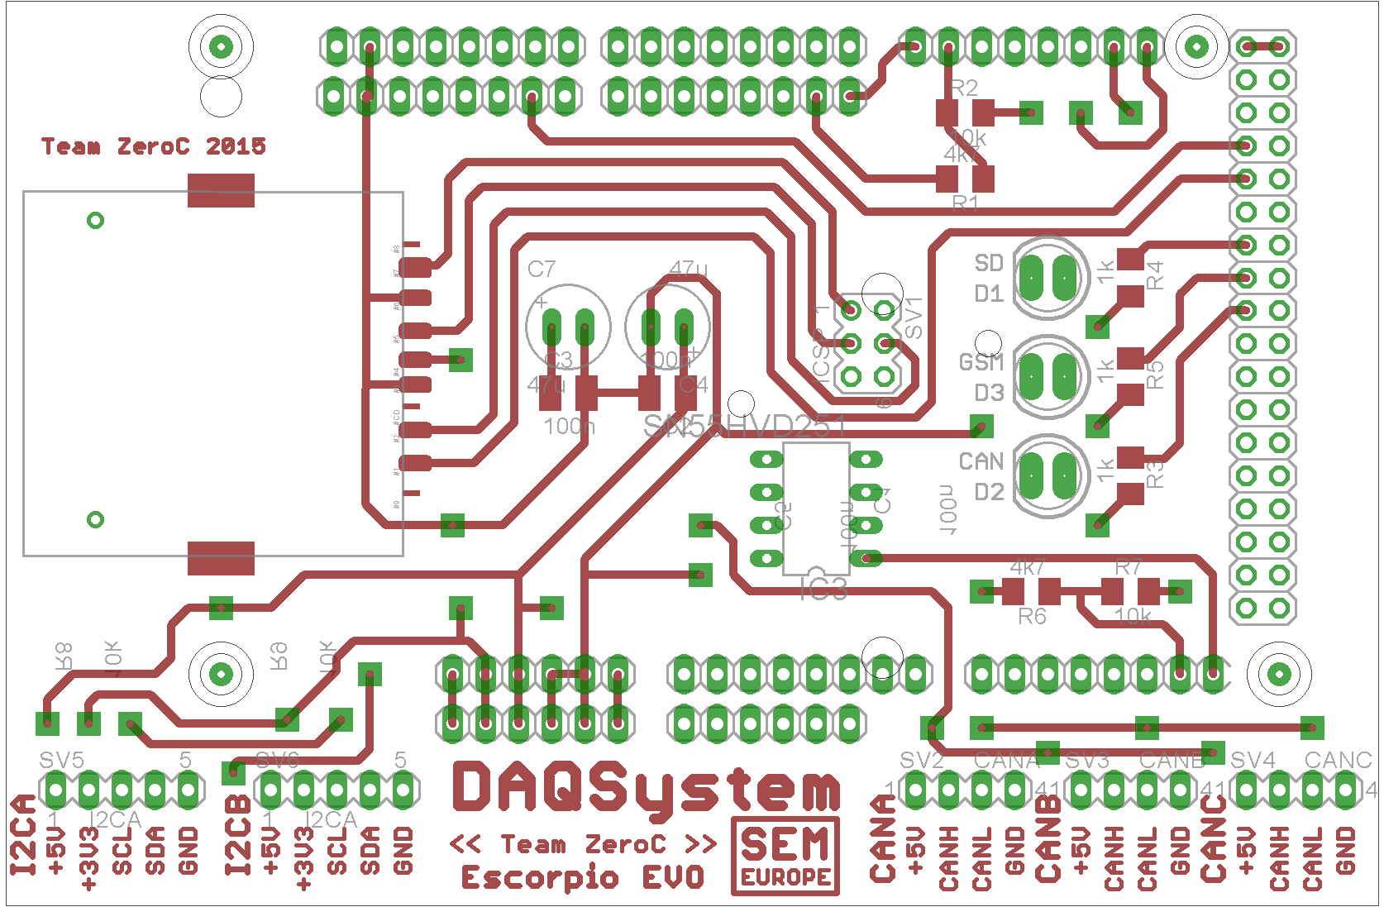

TOP

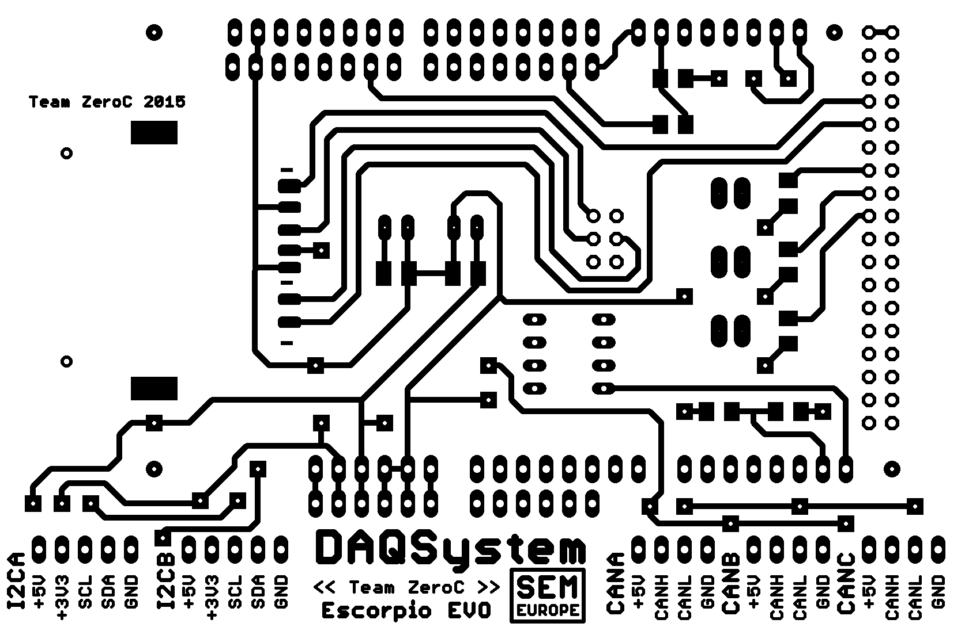

BOTTOM

